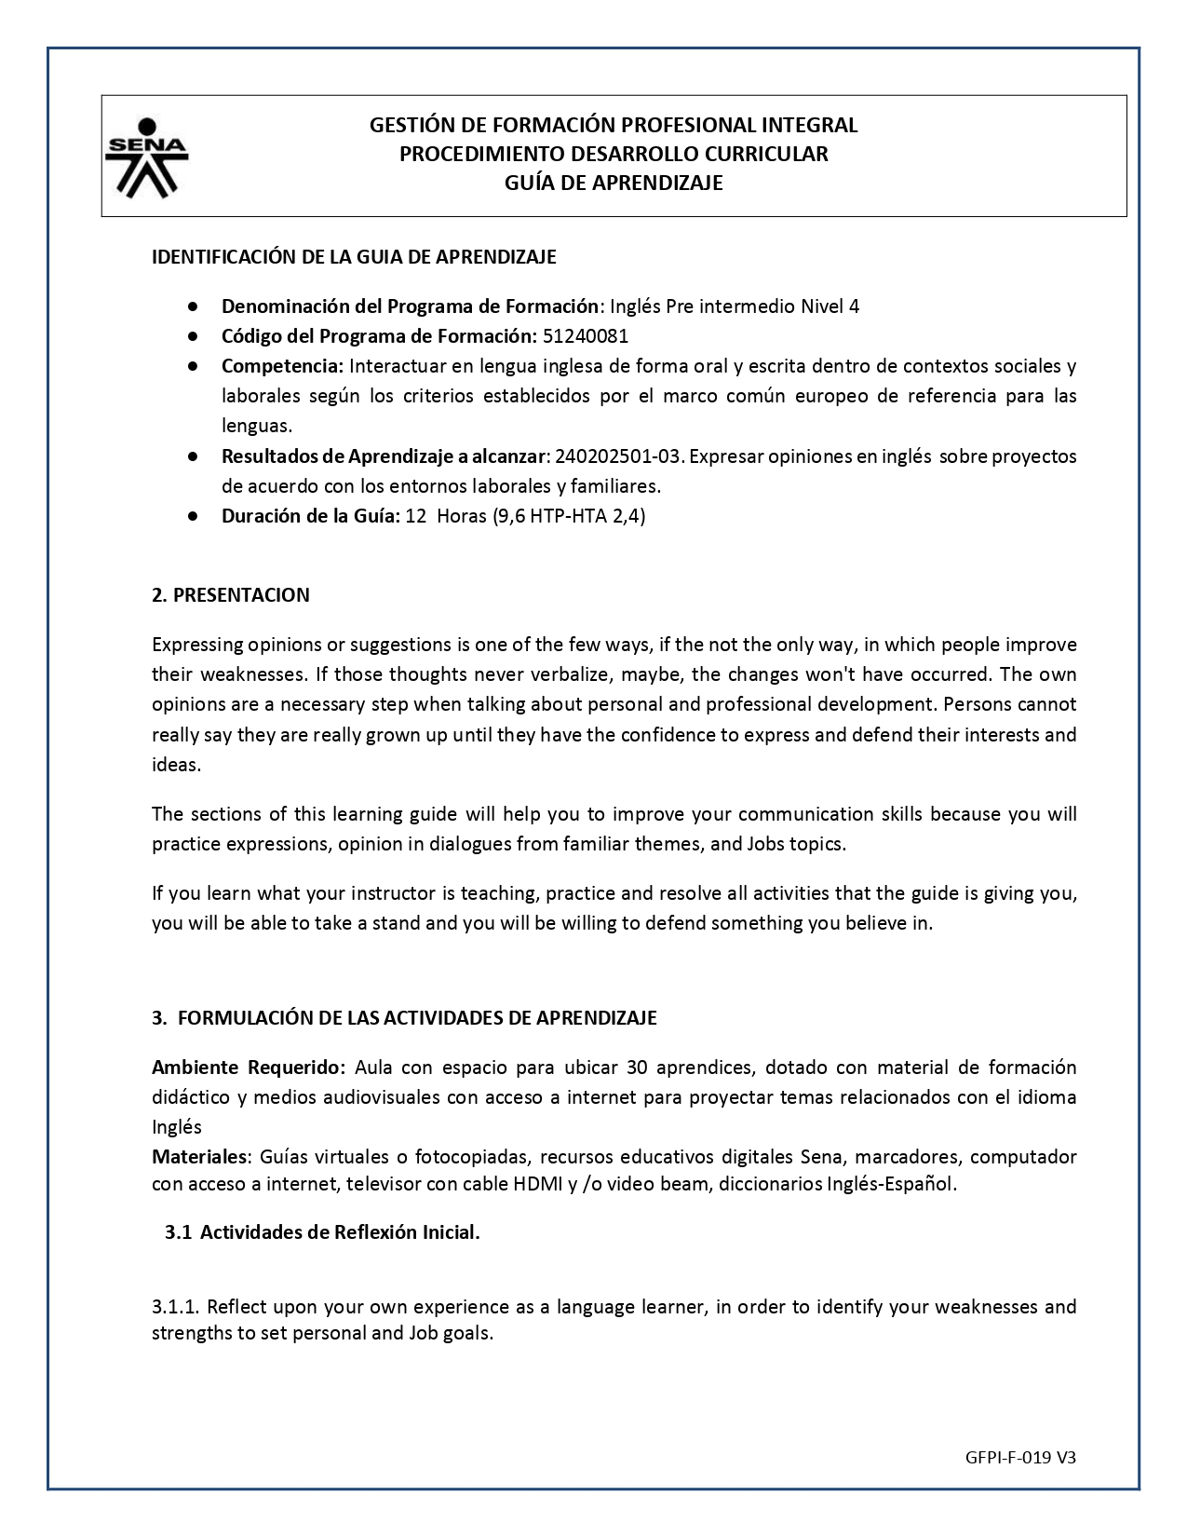

**Activity**

**Screenshot about simple present**

**Names:** Sergio Andrés Tovar Triana - 1803183

**1** Take the screenshots of your results.

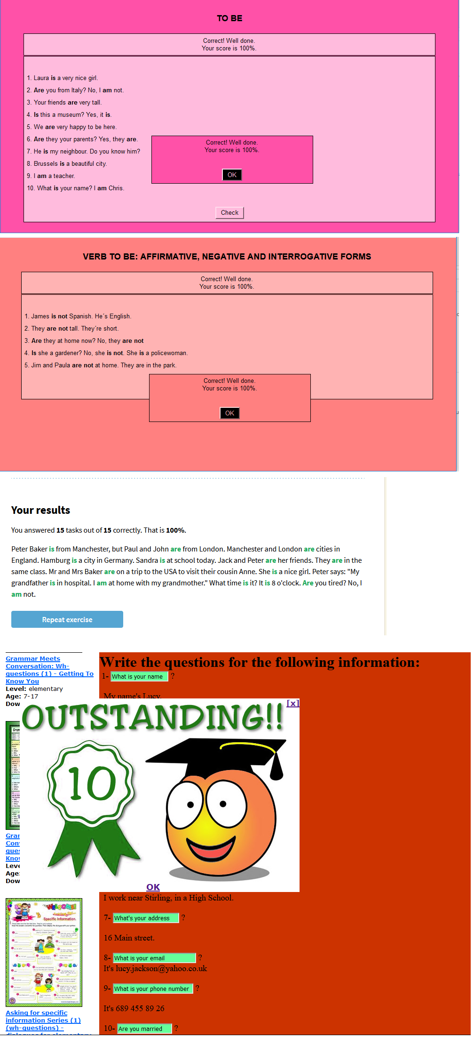

1. James is not Spanish. He´s English.
2. They are not tall. They´re short.
3. Are they at home now? No, they are not
4. Is she a gardener? No, she is not. She is a policewoman.
5. Jim and Paula are not at home. They are in the park.
6. Laura is a very nice girl.
7. Are you from Italy? No, I am not.
8. Your friends are very tall.
9. Is this a museum? Yes, it is.
10. We are very happy to be here.
11. Are they your parents? Yes, they are.
12. He is my neighbour. Do you know him.
13. Brussels is a beautiful city.
14. I am a teacher.
15. What is your name? I am Chris.

You answered **15** tasks out of **15** correctly. That is **100%**.

1. Peter Baker is from Manchester, but Paul and John are from London. Manchester and London are cities in England. Hamburg is a city in Germany. Sandra is at school today. Jack and Peter are her friends. They are in the same class. Mr and Mrs Baker are on a trip to the USA to visit their cousin Anne. She is a nice girl. Peter says: "My grandfather is in hospital. I am at home with my grandmother." What time is it? It is 8 o'clock. Are you tired? No, I am not.

**ASKING FOR PERSONAL INFORMATION**



**Write the questions for the following information:**  
 1- ?  
  
  My name's Lucy.  
  
  2- ?  
  
  I'm 28 years old.  
  
 3- ?  
  
  I'm from Glasgow.  
  
  4- ?  
  
  I live in Stirling.  
  
  5- ?  
  
  I'm a French teacher.  
  
  6- ?  
  
  I work near Stirling, in a High School.  
  
  7- ?  
  
  16 Main street.  
  
  8- ?

It's lucy.jackson@yahoo.co.uk  
  
  9- ?  
  
  It's 689 455 89 26  
  
  10- ?  
  
  No, I'm single.  
  
  11- ?  
  
  I like sports and music.